SIR SYED UNIVERSITY OF ENGINEERING & TECHNOLOGY
COMPUTER SCIENCE & INFORMATION TECHNOLOGY DEPARTMENT

Spring 2025
Cloud Computing (CS-492T)
Assignment # 1

Semester: 6th Batch: 2022F-BCS-152
Announced Date:14-04-25 Due Date:21-04-25
Total Marks: 3 Marks Obtained:
Instructor Name: Engr. Tehmeed Ebaduddin Name: Faisal
CLO # | Course Learning Outcomes (CLOs) | PLO Mapping | Bloom’s Taxonomy
CLO 1 | Describe the core concepts of the cloud computing paradigm | PLO_1  (Academic Education) | C1  (Knowledge)

Q1. Write down the steps to create a VM using one of the major Cloud platforms, such that the name
of resource group and VM should reflect your name. Attach the configuration snapshot and attach
the snapshot of the host machine connecting to the cloud VM.

Steps to Create a VM on Azure

1. Login to Azure Portal
- Go to https://portal.azure.com
- Sign in with your Azure account.

2. Create a Resource Group
- In the search bar, type Resource Groups and click it.
- Click on + Create.
  - Subscription: Select your subscription.
  - Resource Group Name: e.g., Faisal
  - Region: Choose a region close to your location.
- Click Review + Create → Create.

3. Create the Virtual Machine
- In the search bar, type Virtual Machines and click it.
- Click on + Add → + Virtual machine.
- Configure the following:

Basics:
  - Subscription: Same as your resource group.
  - Resource Group: Faisal
  - Virtual machine name: Faisal
  - Region: Same as the resource group.
  - Availability Options: Leave default.
  - Image: Select Ubuntu Server 22.04 LTS (or Windows, depending on your preference).
  - Size: Choose a basic tier like B1s or D2s_v3 for testing.
  - Authentication type: Password or SSH.
  - Username: yourname
  - Password/SSH Key: Set as needed.

Inbound Port Rules:
  - Public Inbound Ports: Allow selected ports
  - Select inbound ports: SSH (port 22) for Linux / RDP (port 3389) for Windows
- Click Next through other tabs or keep default settings.
- Click Review + Create → Create.

4. Wait for Deployment
- It will take a few minutes.
- Once deployed, go to the VM overview page.

5. Connect to VM
- Click Connect:
  - For Linux (SSH):
    - Copy the public IP from Azure VM overview.
    - Open terminal on your local machine:
    - ssh yourname@<public-ip>
  - For Windows (RDP):
    - Download the .rdp file.
    - Open it and enter your credentials.
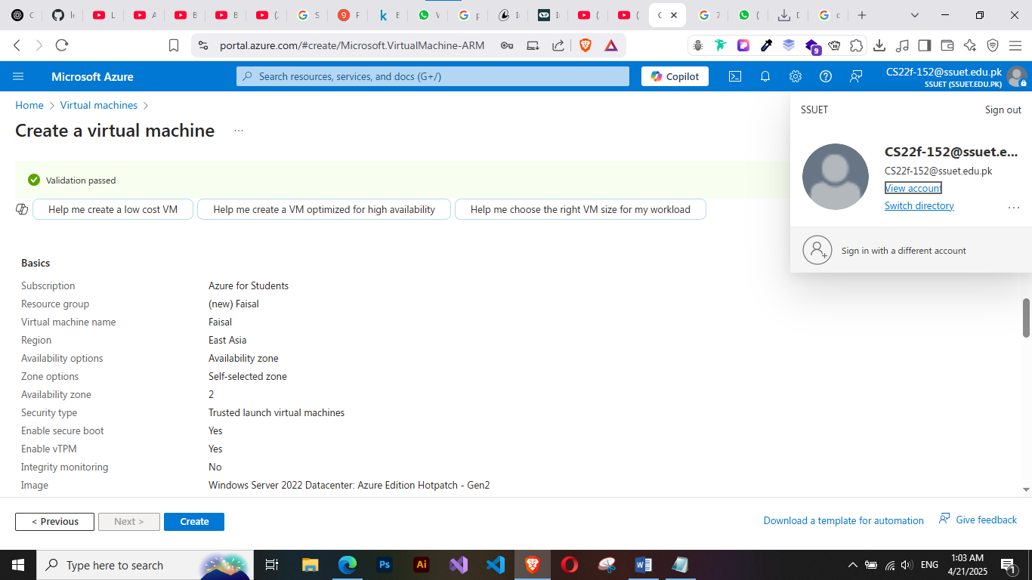
- Configuration

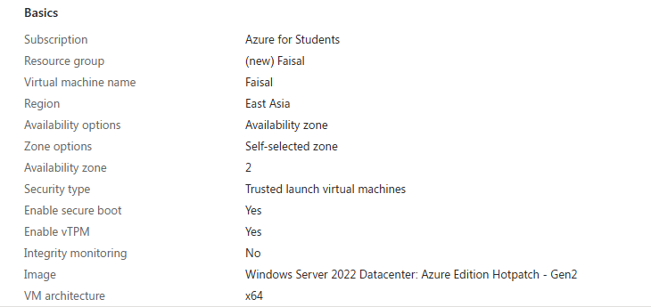

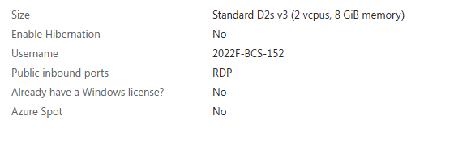

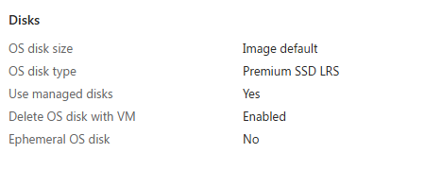

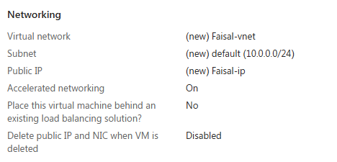

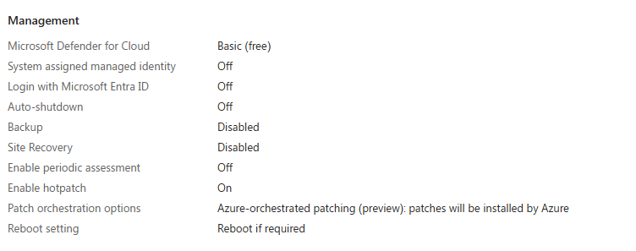
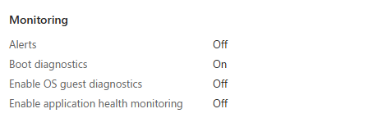

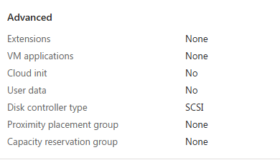

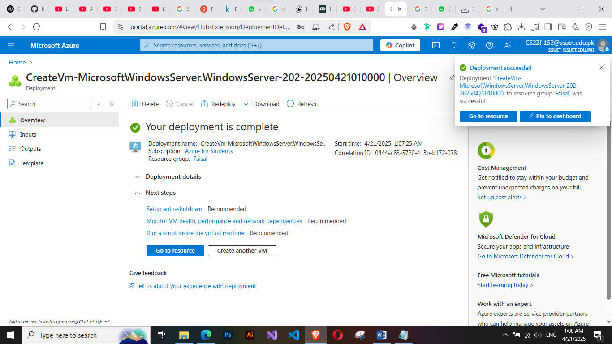

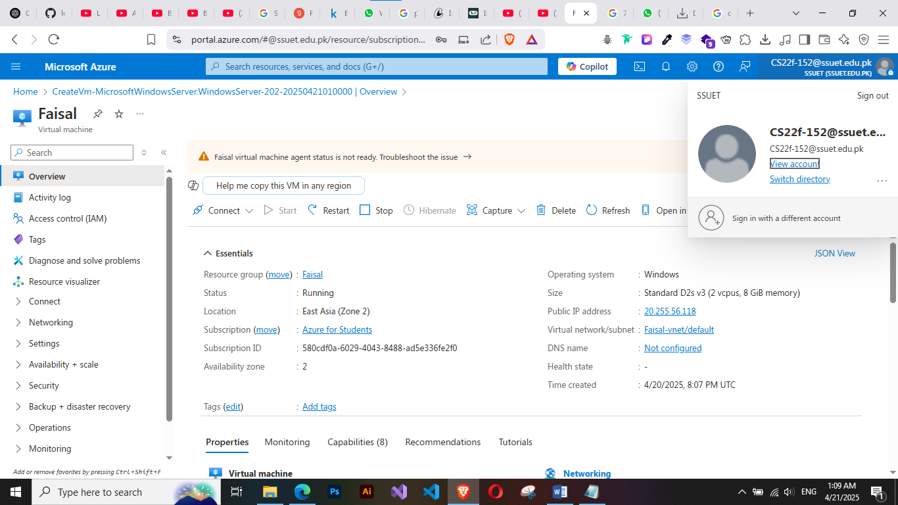

- Host machine connecting to the cloud VM

